Feature List
Actor | Feature | Priority
Campus Community User | Can Edit own Lost Item report before approval | Critical
Campus Community User | Create Found Item report with required detail | Critical
Campus Community User | Can Edit Own Found Item report before approval | Critical
Campus Community User | Can view published Lost and Found reports | Critical
Campus Community User | Can Search and filter reports by type, status, date, and location | Critical
Security Office Staff | Can Edit report content for clarity, accuracy, or policy compliance | Critical
Security Office Staff | Change the status of any report | Critical
Security Office Staff | Close reports when items are resolved | Critical

Story Points
Actor | Feature | Story Points
Campus Community User | Can Edit own Lost Item report before approval | 3
Campus Community User | Create Found Item report with required detail | 3
Campus Community User | Can Edit Own Found Item report before approval | 5
Campus Community User | Can view published Lost and Found reports | 2
Campus Community User | Can Search and filter reports by type, status, date, and location | 5
Security Office Staff | Can Edit report content for clarity, accuracy, or policy compliance | 5
Security Office Staff | Change the status of any report | 3
Security Office Staff | Close reports when items are resolved | 2

Test Cases

User Story 1:
Campus Community User can edit own Lost Item report before approval
Test Case | Input | Expected Output | Actual Output
1 (Success) | Precondition: User is logged in and has an unapproved Lost Item report.  1. Open report "Lost Wallet"  2. Change Description to "Black leather wallet with ID"  3. Click "Save" | The system updates the report and displays the new description.
2 (Failure) | Precondition: User is logged in and opens another user's Lost Item report.  1. Open report  2. Verify that fields are read-only  3. Verify that the "Save" button is disabled | The system prevents editing and the "Save" button is not clickable.

User Story 2:
Campus Community User can create Found Item report with required detail
Test Case | Input | Expected Output | Actual Output
1 (Success) | Precondition: User is on Create Found Item page.  1. Item Name: "Black Backpack"  2. Category: "Bag"  3. Location: "Library 2nd Floor"  4. Date: "2026-03-18"  5. Description: "Backpack with laptop sleeve"  6. Click "Submit" | The system creates the report and displays submitted details.
2 (Failure) | Precondition: User is on Create Found Item page.  1. Leave Item Name empty  2. Fill other fields  3. Verify that the "Submit" button is disabled OR validation message is shown | The system prevents submission or shows validation error for required fields.

User Story 3:
Campus Community User can edit own Found Item report before approval
Test Case | Input | Expected Output | Actual Output
1 (Success) | Precondition: User is logged in and has unapproved Found report.  1. Open report "Phone Found"  2. Change Location to "Student Center"  3. Click "Save" | The system updates and displays the modified report.
2 (Failure) | Precondition: User is logged in and report is already approved.  1. Open approved report  2. Verify fields are read-only  3. Verify that the "Save" button is disabled | The system prevents editing and no changes can be made.

User Story 4:
Campus Community User can view published Lost and Found reports
Test Case | Input | Expected Output | Actual Output
1 (Success) | Precondition: User is logged in.  1. Open "View Reports" page | The system displays all published reports.
2 (Failure) | Precondition: Unpublished reports exist.  1. Open "View Reports" page  2. Verify unpublished reports are not visible | The system shows only published reports.

User Story 5:
Campus Community User can search and filter reports by type, status, date, and location
Test Case | Input | Expected Output | Actual Output
1 (Success) | Precondition: Reports exist in system.  1. Filter Type: "Lost"  2. Location: "Library"  3. Click "Search" | The system displays reports matching filters.
2 (Failure) | Precondition: Reports exist.  1. Filter Location: "NonExistingPlace"  2. Click "Search" | The system displays no results.

User Story 6:
Security Office Staff can edit report content for clarity, accuracy, or policy compliance
Test Case | Input | Expected Output | Actual Output
1 (Success) | Precondition: Staff user is logged in.  1. Open report  2. Change Description to "Clear and appropriate wording"  3. Click "Save" | The system updates report content successfully.
2 (Failure) | Precondition: Regular user is logged in.  1. Open report  2. Verify fields are read-only  3. Verify that the "Save" button is disabled | The system prevents editing and restricts access to staff-only functionality.

User Story 7:
Security Office Staff can change the status of any report
Test Case | Input | Expected Output | Actual Output
1 (Success) | Precondition: Staff user is logged in.  1. Open report  2. Change status to "Approved"  3. Click "Save" | The system updates report status successfully.
2 (Failure) | Precondition: Regular user is logged in.  1. Open report  2. Verify that status field is read-only  3. Verify that the "Save" button is disabled | The system prevents status changes for unauthorized users.

User Story 8:
Security Office Staff can close reports when items are resolved
Test Case | Input | Expected Output | Actual Output
1 (Success) | Precondition: Staff user is logged in and report is resolved.  1. Open report  2. Click "Close Report" | The system marks report as closed.
2 (Failure) | Precondition: Staff user is logged in and report is NOT resolved.  1. Open report  2. Verify that the "Close Report" button is disabled | The system prevents closing unresolved reports.

User Acceptance Criteria

User Story | Acceptance Criteria | Status
As a Campus Community User, I can edit lost/found report before approval so that I can guarantee accurate information displayed in the directory | - Given the user is logged in as a community user and the user has submitted a lost/found report that has not been approved  - When the user goes to the submitted report and clicks the edit option  - Then they can modify the report and save it | Critical
As a Campus Community User, I can create found item report with required detail so that I can guarantee I display the relevant information that determines what items have been found and what are lost | - Given the user is logged in as a community user  - When the user navigates to the page “Create Report”  - Then they can enter information based off of the alleged found item | Critical
As a Campus Community user, I can view published lost & found reports So that I know which reports show relevant lost & found items in the directory | - Given the user is logged in as a community user  - When the user navigates to the directory page  - Then they can see the lost & found reports showcased | Critical
As a Campus Community user, I can search/filter reports by type, status, date, and location So that I can quickly find relevant lost & found items. | - Given the user is logged in as a community user  - When the campus community user goes to the search bar to find reports based on different filters  - Then they can see the reports they searched for | Critical
As a Security Office staff, I can edit report content for clarity & accuracy, so that relevant lost & found items are accurate | - Given the user is logged in as a security office staff  - When the user clicks the “edit” button under reports  - Then they can modify and enter accurate information | Critical
As a Security Office staff, I can change the status of any report So that the reports display the correct status. | - Given the user is logged in as a security office staff and views a report  - When the staff selects the status and saves the new changes  - Then the report should be updated and displayed accurately | Critical
As a SO Staff, I can close reports when items are resolved So that the directory only displays reports that are open to the public | - Given the user is logged in as a security office staff and clicks the “edit” button  - When they enter close report button after resolving  - Then the report should be closed and not be displayed to the public | Critical

Use Case Diagram
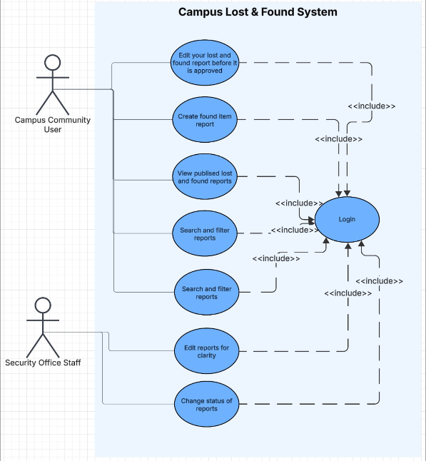

Days We Had Scrum Meeting
- Sundays 8:30-8:50 Am
- Wednesday 9:00-9:15 Am
- Friday 9:00-9:15 Am

